Assignment 10.2

4. Return the first name, last name and city of all customers who live in Canada. Order the results
first by the last then by the first name.

ANS:
- SELECT customer.first_name,customer.last_name,city.city,country.country
FROM customer
JOIN address ON customer.address_id = address.address_id
JOIN city ON address.city_id = city.city_id
JOIN country ON city.country_id = country.country_id
WHERE country.country='Canada'
ORDER BY customer.last_name,customer.first_name;

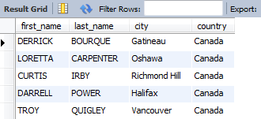

5. How many customers are from Brazil??
ANS:
- SELECT country.country, COUNT(customer.customer_id) AS total_customers
FROM customer
JOIN address ON customer.address_id = address.address_id
JOIN city ON address.city_id = city.city_id
JOIN country ON city.country_id = country.country_id
WHERE country.country='Brazil';

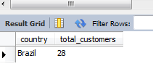

6. Return the "popular countries"? (that is, the ones with more than 20 customer). For each
such country, return its name and its correspond number of customers. Order the result by the
number of customers (descending).

ANS:
- SELECT country.country, COUNT(customer.customer_id) AS total_customers
FROM customer
JOIN address ON customer.address_id = address.address_id
JOIN city ON address.city_id = city.city_id
JOIN country ON city.country_id = country.country_id
GROUP BY country.country
HAVING COUNT(customer.customer_id)>20
ORDER BY total_customers DESC,country.country;

